.
Abstract— The improvement in vehicle safety can be achieved by limiting the vehicle speed based on the road condition. In this paper, we first introduce an idea of road friction preview through CAVs with shared roadway databases. Then we present an algorithm to generate a longitudinal vehicle velocity limit profile based on the desired path curvature and the preview of path friction. Moreover, the preview distance is discussed to ensure the vehicle has sufficient time to take action for upcoming hazardous situations. Finally, the efficiency of work is demonstrated through an application case where a vehicle with a simple driving controller can follow the path well with the preview of velocity.
Improve CAVs Safety by Proper Vehicle Longitudinal Speed Planning with the Preview of Path Friction and Curvature*
Liming Gao, Craig Beal, Kshitij Jerath, Daniel Fescenmyer, Sean Brennan. IEEE Member

INTRODUCTION
The traffic accident is fatal and has a huge negative influence on economic costs. [follow some data from reference] Many factors attribute to safety, but a large part of the accidents are caused by slick roads (snow, ice, raining, etc.) and overspeeding. (make it positive: maximize the safety throughout the highway system in any condition)
One way to make cars safer is the development of the ADASs (Advanced Driver Assistance Systems) such as EBS, LKA, and ESC, etc., which can assist the drive to follow the desired path stably in hazardous situations. [follow with summary and examples of ADAS contollers]
Lateral control,
Longitudinal control,
Autonomous racing,
However, many of the controllers are activated only when the vehicle states are out of stability. For example, the driver may take an emergency brake when entering into a slick road or a split friction road. [ follow with more examples and summary]. The controller has a stable region. Consequently, the controller even fails to keep the vehicle stable if the road condition changes intensively. [ref]
(Different from the reaction controller, researchers developed the proactive envelope controller with real-time road friction estimation, which can keep the vehicle within a stable region. But it still can not prevent the vehicle from veering away from the desired path when the road condition changes intensively.)
Existing research has shown that appropriate longitudinal velocity planning is vital when following a path with tight curvature change [1]. The idea is to reduce vehicle speed before a potentially dangerous situation is reached, in contrast with widely used stability control systems that only react once loos of control is imminent. In addition, with small velocity, the vehicle could have a larger stable region to follow the desired path with [2], [3]. Reaction to emergency brake or something, force the vehicle recover stable, we can

Another drawback is that it may cause a traffic jam.
(need a better transition)However, they only consider the variation of curvature, and little attention has been paid to the road surface friction condition changing when conducting longitudinal velocity planning. For example, if the vehicle can preview the path friction reduction and slow down appropriately before entering the slick region, then even not need a complicated algorithm to stably. The prior estimation of friction and peak tire force, before the slick region is reached, allows a vehicle chassis control system to work more reliably and proactively [2]., with small velocity, the vehicle could have a larger stable region [2], [3], and then even a simple steering control algorithm can enable the vehicle to follow the path well.
However, it is almost impossible to preview the large area road condition just through the intelligence of individual vehicle, where each vehicle itself constantly measuring and navigating the world using in-vehicle system. Fortunately, a potential solution to preview the road surface friction condition can be motivated by the increasing research into the cyber-physical system, especially Connected and Autonomous Vehicles (CAV). This solution takes advantage of network intelligence instead of individual intelligence, where the pre-measured information is shared within the network including vehicle-vehicle, vehicle-infrastructure, and vehicle-database systems. In this network, each vehicle and roadside unit can measure local road friction and share it with the cloud database. Each vehicle can query the aggregated information from the shared database. A demo framework of this is shown in Fig. 1.
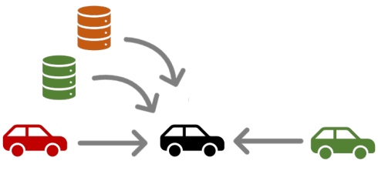
Figure 1. A strategy of road friction preview with a roadside shared roadway database. (need a better diagram to show the data sharing idea and more words to describe it) The database can leverage shared intelligence to substantially improve the operation of each individual in the population.
The improvements in vehicle safety can be achieved by limiting the vehicle speed based on the road condition. In this paper, we introduce an idea of road friction preview through database-informed CAV. Then inspired by the work in DDL on vehicle dynamics at the limits of handing [4]–[6], we present an algorithm to generate a longitudinal vehicle velocity limit profile for a given desired path with the preview of path friction. Moreover, the preview distance is discussed to ensure the vehicle has sufficient time to take action for upcoming hazardous situations. You could say something like “Moreover, relationships are established between data confidence, preview distance, and vehicle speed for a vehicle traversing a roadway system augmented with such a system.”
The remainder of this paper is organized as follows: Section II discusses the velocity limit profile planning based on the tire limits. Section III analyzes the preview distance. Section IV shows an application case. Finally, a conclusion section summarizes the main results of the work.

Vehicle Longitudinal Velocity Planning Given a Reference Path
This section presents the generation of minimum-time speed profile which vehicles can achieve without exceeding available road friction/vehicle handing limits [7]. At first, the approach to describe the path by s and κ is introduced and then followed by a detailed velocity planning method.
Path tracking while cornering at the limit of friction

A. Vehicle Chassis Model and Tire Friction Limits
The vehicle dynamic equations for the planar three states single track model shown in Fig. 2 are:
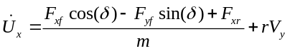
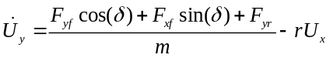
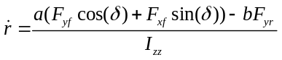
where longitudinal velocity U_{x}, lateral velocity V_{y} and yaw rate r are the three states. The vehicle parameters include the vehicle’s mass m, yaw moment of inertia I_{zz}, front wheel steering angle δ, and a and b the distance from the vehicle’s center of gravity to the front and rear axle respectively. Forces F_{xf}, F_{yf}, F_{xr}, F_{yr} are the forces acting on the front and rear tires.

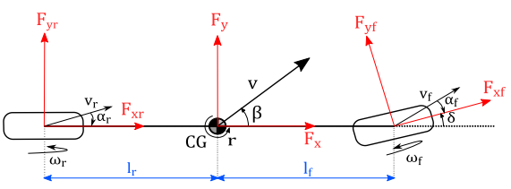
Figure 2. Planar single-tack vehicle chasis model (need update this diagram indicating Ux and Uy, a and b)
The available longitudinal force F_{x} and lateral force F_{y} at each tire is constrained by friction circle:
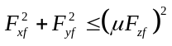
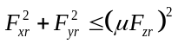
where μ is the road-tire friction coefficient, and F_{zf} and F_{zr} are the normal force at the front and rear axle respectively.
Determining the limit speed profile requires the vehicle to utilize all the available tire friction to generate forces so that vehicle can operate at acceleration limits to achieve the maximum safe speed [8]. It implies that all tire forces need to remain on the boundary of the friction circle:
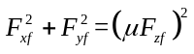
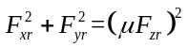
Fig. 3 shows the tire force when maneuvering through a path corner. The boundary of the friction circle depends on the road-tire friction coefficient.
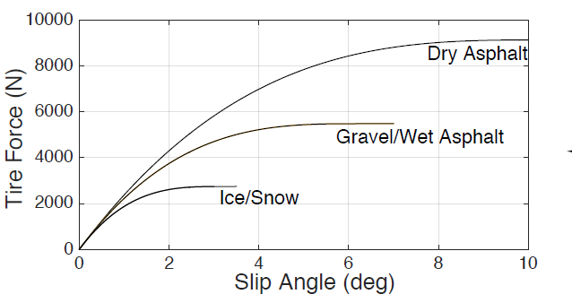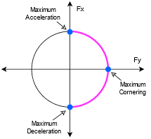
Figure 3. A plot of 0.9g and 0.2g friction circle.
To maximize the tire forces, the racecar drivers can operate a vehicle at a friction limit. it is hard for a driver to operate vehicle like racer, thus a adjust parameter is added

As we are interested in the longitudinal dynamic, assume the lateral states are steady:
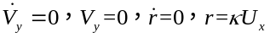
where κ is the path curvature.
Substituting , , and into yields the longitudinal dynamics equation:
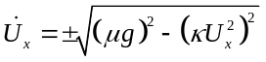

The parameters μ and κ depend on the path position. Thus we introduce the path description method in the following session.

, The maximum performance of vehicle can be achieved by “driving at the traction circle”, which implies the tire force remains on the edge of friction circle but not exceeding its bounds.

B. Path Representation
The use of clothoid for general vehicle path planning is not uncommon. Refer to [9] Minimum curvature [10] and optimal time.
Fig. 3 shows a sample curvy path.
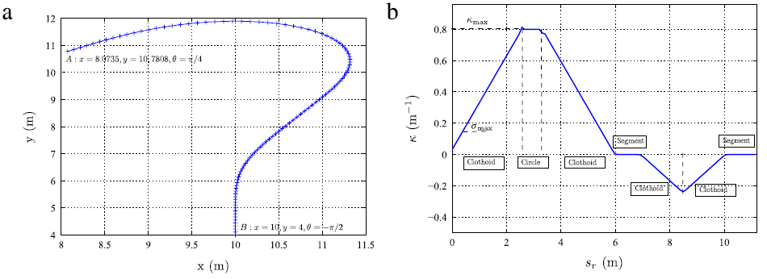
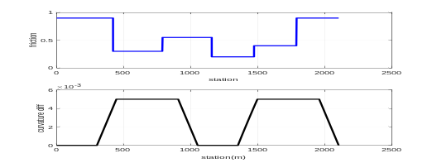
Figure 3. A smaple path with friction varitation
In real-world, the grade of the path also has a significant influence on the vehicle acceleration and deceleration behavior. We may need to include the grade term.

C. Velocity Profile Generation
Velocity planning has a significant impact on driving safety, especially when vehicles drive on a road with changing friction and geometry. In this paper, velocity generation is performed by considering the tire friction limits constraints. The approach presented in this paper is inspired by those works: three passes [7], nonlinear optimization [1], segment and iteration [11], where a velocity profile is planned given the path curvature.
For a single mass vehicle model:
[equations ]

Add an adjusting parameter to the friction limit to compensate for the friction estimation uncertainty or just for the conservation consideration. In this way, the friction circle can be represented by a relationship between and as follows:
[equations]

The first step is to generate the speed profile is to find the maximum permissible steady state vehicle velocity with zero longitudinal acceleration. If ignore the load transfer and road grade, this is given by (1):
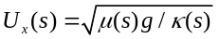

Finally, the longitudinal acceleration is:

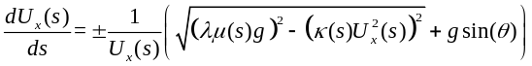
where: λ is an adjusting parameter

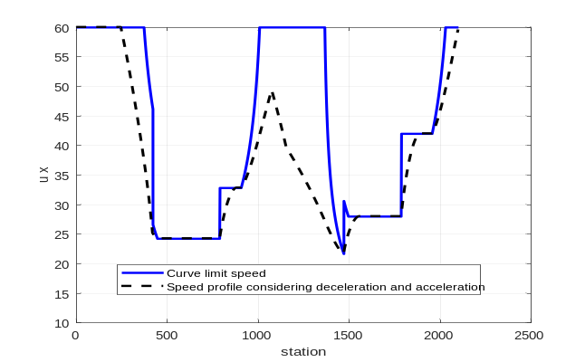
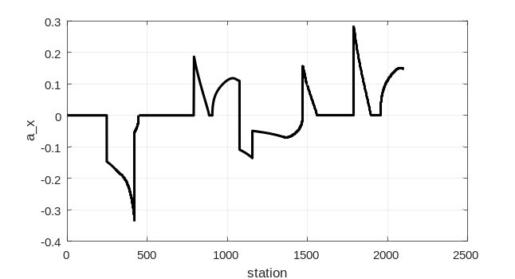
Figure 4. A a sample of velocity profile and the acceleration

In (2), λ can be chosen as a value smaller than 1 for some speed conservation.

Preview Distance
In this section, we discuss the friction preview distance, which indicates how much friction data a vehicle needs to query from a database so that it can have sufficient time to take action for any upcoming situation.
Strategy can be: find the most critical scenario.

A. Minimum Preview Distance given the Vehicle Current States
The worst case is entering a circle, with a sudden friction decrease.
The minimum curvature can be obtained from the path, and the minimum friction can be assumed to be 0.1 for conservation.
The distance is a function of Ux, ax, max(κ), min (μ)
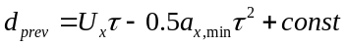
Case discussion:

Most human drivers with the required vision can only see less than XXXm even on a clear day when driving. Unfortunately, the visibility reduces a lot at adverse weather where dangerous road condition occurs.
And the driver’s sight is limited at corners and hills.

B. Speed Profile Depends on the Preview Distance
The vehicle needs to move slower if with less visibility.
Both road condition and preview distance has an influence to the vehicle speed profile.

Application Case and Simulation Results
A vehicle with rear driving, front steering, under steering, or oversteering.
A path with a length of 5 km, compare the velocity results with and without the preview of friction.
A simple driver controller can follow the path well with the preview of friction.
A controller behavior with limited friction preview distance.

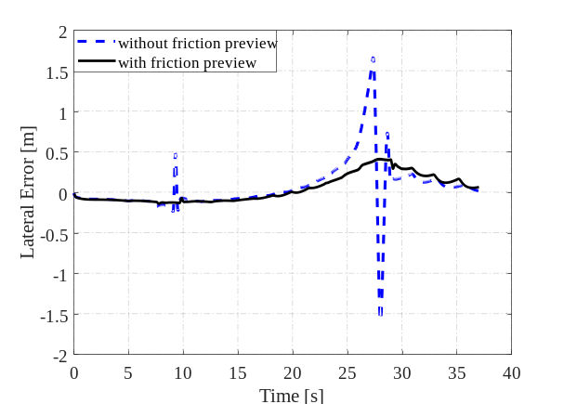
Figure 5. An apllication of preview

Conclusion
In this paper, we ... . The idea behind this is to extend individual intelligence with network intelligence.
Acknowledgment
This material is based upon work supported by the National Science Foundation under grant no. CNS-1932509 “CPS: Medium: Collaborative Research: Automated Discovery of Data Validity for Safety-Critical Feedback Control in a Population of Connected Vehicles”. And CNS-XXX, Dr. Beal and Dr. Jerath
References
- G. O. Young, “Synthetic structure of industrial plastics (Book style with paper title and editor),” in Plastics, 2nd ed. vol. 3, J. Peters, Ed. New York: McGraw-Hill, 1964, pp. 15–64.

[1] H. Cao, X. Song, S. Zhao, S. Bao, and Z. Huang, “An optimal model-based trajectory following architecture synthesising the lateral adaptive preview strategy and longitudinal velocity planning for highly automated vehicle,” Veh. Syst. Dyn., vol. 55, no. 8, pp. 1143–1188, 2017, doi: 10.1080/00423114.2017.1305114.
[2] C. E. Beal and C. Boyd, “Coupled lateral-longitudinal vehicle dynamics and control design with three-dimensional state portraits,” Veh. Syst. Dyn., vol. 57, no. 2, pp. 286–313, 2019, doi: 10.1080/00423114.2018.1467019.
[3] C. G. Bobier-Tiu, C. E. Beal, J. C. Kegelman, R. Y. Hindiyeh, and J. C. Gerdes, “Vehicle control synthesis using phase portraits of planar dynamics,” Veh. Syst. Dyn., vol. 57, no. 9, pp. 1318–1337, 2019, doi: 10.1080/00423114.2018.1502456.
[4] J. Subosits and J. C. Gerdes, “Autonomous vehicle control for emergency maneuvers: The effect of topography,” Proc. Am. Control Conf., vol. 2015-July, pp. 1405–1410, 2015, doi: 10.1109/ACC.2015.7170930.
[5] K. Kritayakirana and J. C. Gerdes, “Autonomous vehicle control at the limits of handling,” Int. J. Veh. Auton. Syst., vol. 10, no. 4, pp. 271–296, 2012, doi: 10.1504/IJVAS.2012.051270.
[6] P. A. Theodosis and J. C. Gerdes, “Nonlinear optimization of a racing line for an autonomous racecar using professional driving techniques,” in ASME 2012 5th Annual Dynamic Systems and Control Conference Joint with the JSME 2012 11th Motion and Vibration Conference, DSCC 2012-MOVIC 2012, 2012, vol. 1, pp. 235–241, doi: 10.1115/DSCC2012-MOVIC2012-8620.
[7] N. R. Kapania, J. Subosits, and J. C. Gerdes, “A Sequential Two-Step Algorithm for Fast Generation of Vehicle Racing Trajectories,” J. Dyn. Syst. Meas. Control. Trans. ASME, vol. 138, no. 9, 2016, doi: 10.1115/1.4033311.
[8] W. C. Mitchell, R. Schroer, and D. B. Grisez, “Driving the traction circle,” SAE Tech. Pap., no. 724, 2004, doi: 10.4271/2004-01-3545.
[9] J. Villagra, V. Milanés, J. Pérez, and J. Godoy, “Smooth path and speed planning for an automated public transport vehicle,” Rob. Auton. Syst., vol. 60, pp. 252–265, 2012, doi: 10.1016/j.robot.2011.11.001.
[10] H. A. Hamersma and P. S. Els, “Longitudinal vehicle dynamics control for improved vehicle safety,” J. Terramechanics, vol. 54, pp. 19–36, 2014, doi: 10.1016/j.jterra.2014.04.002.
[11] R. Solea and U. Nunes, “Trajectory planning with velocity planner for fully-automated passenger vehicles,” IEEE Conf. Intell. Transp. Syst. Proceedings, ITSC, pp. 474–480, 2006, doi: 10.1109/itsc.2006.1706786.

 *Research supported by NSF. Liming Gao is a graduate student in Mechanical Engineering at The Pennsylvania State University, University Park, PA 16803, USA (e-mail: lug358@ psu.edu). Craig Beal is with Department of Mechanical Engineering, Bucknell University, Lewisburg, PA 17837, USA (e-mail: cbeal@bucknell.edu) Sean Brennan is with the Department of Mechanical Engineering, The Pennsylvania State University, University Park, PA 16803, USA (e-mail: snb10@psu.edu). IEEE Member.

